Fontys University of Applied Sciences

Eindhoven, The Netherlands

Project Plan

Procp

airport Luggage simulation

Team IT Rockstars| 12-September -2020

**Group E**

**Team members:**

Aleksander Sopiqoti

Delal Aktas

Fadi Abboud

Emad Albouni

Obaid Ghafoori

Ralia Larmonie **Tutor:** Mr. Emin Thaqi

Table of Contents

Version History **2**

Project statement **2**

Client **2**

Project Group **3**

Way of working **3**

Current Situation **4**

Problem Description **4**

Project Goal **4**

Deliverables and non-deliverables **5**

Project Constraints **5**

Project Risks **6**

Project Phasing **7**

Critical Path/ Dependencies **7**

**Gantt Chart** **8**

Activities Description **9**

## Version History

The table below describes the main changes that were made during the development of the project plan.

|  |  |  |  |
| --- | --- | --- | --- |
| Version | Created on: | Reviewed by: | Remark |
| 1.0 | 01.09.2020 |  |  |
| 2.0 | 12.09.2020 |  |  |

## Project statement

## Client

The formal client for this project is Mr. Emin Thaqi, who is working at SIM Software Inc. the communication between our team and the client will be taking place via our project leader – Aleksander Sopiqoti.  The details of both the parties can be find as follows:

|  |  |  |  |  |
| --- | --- | --- | --- | --- |
| Description | Name | Email | Phone | Location |
| Client | Emin Thaqi | e.thaqi@fontys.nl | +31610852870 | R10/MS-Teams |
| Project Leader | Aleksander Sopiqoti | a.sopiqoti@student.fontys.nl | +31643712770 | MS-Teams |

## Project Group

|  |  |  |
| --- | --- | --- |
| Project Member | Role | Contact |
| Aleksander Sopiqoti | Debugging & Git responsible, Project leader | a.sopiqoti@student.fontys.nl |
| Delal Aktas | Documentation writer, Software developer | d.aktas@student.fontys.nl |
| Fadi Abboud | Simulation designer, Documentation writer | f.abboud@student.fontys.nl |
| Emad Albouni | Database designer, Lead Software developer | e.albouni@student.fontys.nl |
| Obaid Ghafoori | Database designer, Software developer | o.oghafoori@student.fontys.nl |
| Ralia Larmonie | Documentation writer, Software developer | r.larmonie@student.fontys.nl |

## Way of working

The way of working during the project is decided within the group and there is a separate document “Collaboration Contract”. Where, we agreed upon several things regarding the attendance, absence, communication, deadlines and the consequences of not complying with them. We will have weekly meetings as a group to discuss what we have done so far and also how to proceed moving forward with the project.

WhatsApp and Microsoft Teams will be used as the means of communication. For the documentation and task management, Microsoft Teams is the chosen platform. For the development of the application, the group will work with GitLab.

## Current Situation

Our team was contacted by Mr. Emin Thaqi, who is a representative of SIM Software Inc., requesting an application about a simulation software. The client and SIM Software Inc. have not previously used such an application before and are curious and eager to implement it in their company. The project has to cover a set of requirements which have been given to us.

## Problem Description

SIM Software Inc. needs a fully functioning Airport Luggage Simulation software. The problem is that the company has not yet used this kind of software to address this issue, which means it has no expertise in it. A simulation software will be highly beneficial and useful for the client since it illustrates real-life situations/scenarios of transporting.

## Project Goal

The purpose of this project is to build an application for SIM Software Inc. based on their requirements. To satisfy their request, we will be developing an application, which would simulate the best and most efficient way to transport luggage in an airport. Our goal is to deliver a functional simulation application within the time frame we are given. This will take place through continuous implementation phases and testing in order to provide the final version.

## Deliverables and non-deliverables

Deliverables :

1. Source Code
2. Final Product (Application)
3. Project Plan
4. URS (User Requirements Specification with functional/non-functional requirements)
5. Database (ERD, for storing simulation models)
6. Design Document
7. Process report (Agenda meeting documents)
8. Video Guide for utilizing the software.

             Non-deliverables:

1. Technical Hardware
2. Manual for the application

## Project Constraints

* The time for the entire project is restricted to 18 weeks and this may have an effect on the quality of the project.
* The lack of resources may pose a hindrance on the efficiency of completing the project. By resources, it means that we may have internet shortage or computer crashes (blue screen/ or just faulty PC), which could hinder our ability to proactively work on our project. Which in turn can result in a lackluster product.

## Project Risks

1. Risk: Miscommunication between us and the client.
   1. Probability: Probable
   2. Impact: Medium
   3. Prevention measures: Through maintaining a good flow of communication between us and the client.
   4. If it still occurs: Contact the client and discuss how we could maintain a better flow of communication.
2. Risk: Our client is unsatisfied with our deliverable.
   1. Probability: unlikely
   2. Impact: High
   3. Prevention measures: Add the new requirements
   4. If it still occurs: Update our requirements to our client’ satisfaction.
3. Risk: We could suffer a loss of data.
   1. Probability: Unlikely
   2. Impact: High
   3. Prevention measures: We would be making use of GIT repository hosting service (GitLab).
   4. If it still occurs: We could revert to the last save version.

## Project Phasing

## Critical Path/ Dependencies

The blue boxes represent the critical path and the green boxes are the dependencies.  
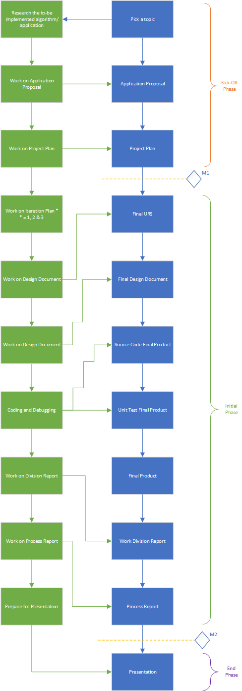

## Gantt Chart

## 

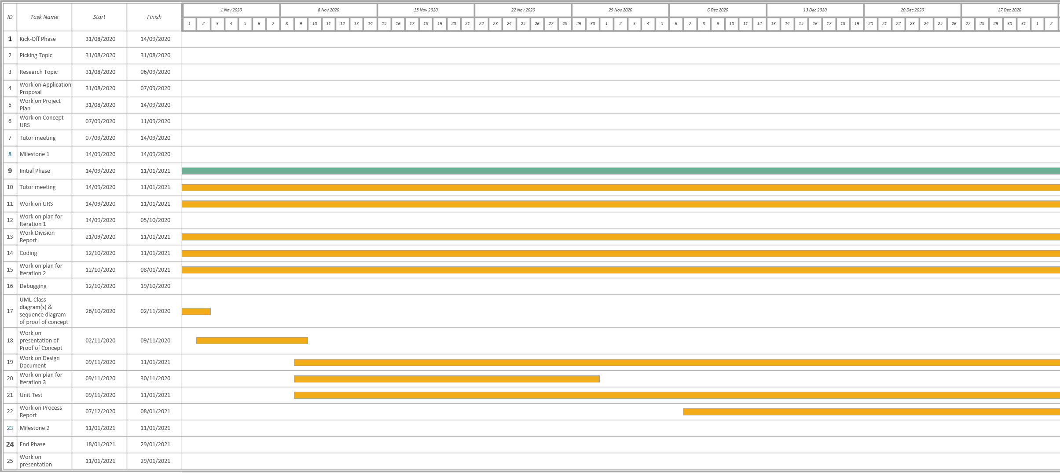

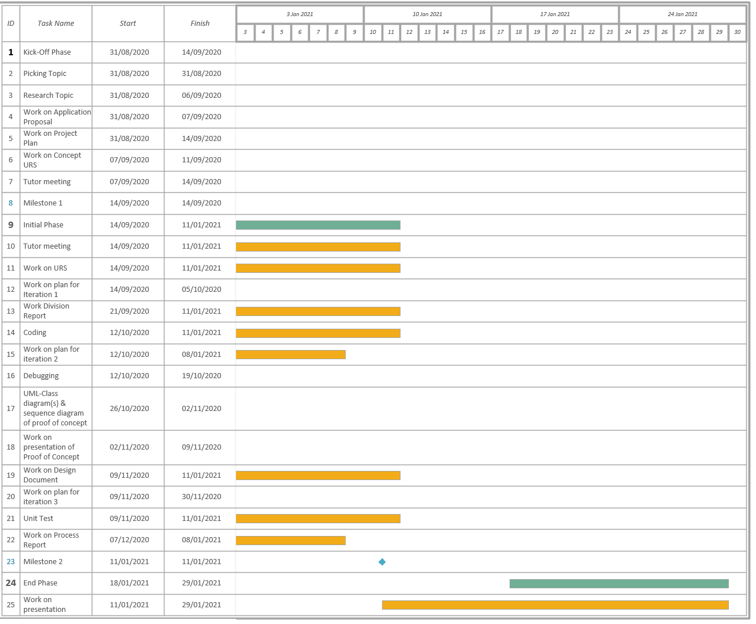

## 

## Activities Description

|  |  |  |  |  |  |  |
| --- | --- | --- | --- | --- | --- | --- |
| #Nr | Activity | Description | Start Date | End Date | Time Consumption (hours) | Completed (%) |
| 1. 1 | Picking a topic | As a group we discussed the topic we would want to choose. | 31-August-2020 | 31-August-2020 | 3 | 100 |
|  | Create a logo and a company name | We came up with a name for our company and a logo. | 31-August-2020 | 31-August-2020 | 3 | 100 |
|  | Research the airport luggage simulation | Doing research on algorithms that may. | 31-August-2020 | 7-September-2020 | 14 | 40 |
|  | Work on application proposal | Here we’ll give a picture of what the goal of this project, key features of the application will be explained | 31-August-2020 | 7-September-2020 | 20 | 80 |
|  | Work on Project plan |  | 31-August-2020 | 14-September-2020 | 26 | 80 |
|  | Work on URS | As a group we will work on listing the requirements to be able to create functioning application. | 7-September-2020 | 11-January-2021 | 148 | 0 |
|  | Work on plan for iteration 1 | As a group we will decide what we will do for this iteration of implementation and testing | 14-September-2020 | 5-October-2020 | 36 | 0 |
|  | Work on Work Division Report | As a group we will work on how we will devise the work between all of us | 21-September-2020 | 11-January-2021 | 96 | 0 |
|  | Coding | Programming on the to-be final product for the client (application) | 12-October-2020 | 11-January-2021 | 126 | 0 |
|  | Debugging | We will work on removing errors from the application | 19-October-2020 | 26-October-2020 | 18 | 0 |
|  | Work on plan for iteration 2 | As a group we will decide what we will do for this iteration of implementation and testing | 12-October-2020 | 26-October-2020 | 48 | 0 |
|  | UML Class – and Sequence Diagram for Proof of Concept | As group we will work on designing the UML-Class diagram and non-trivial Sequence Diagram for the proof of concept | 26-October-2020 | 2-November-2020 | 60 | 0 |
|  | Work on Design Document | As a group we will work on | 9-November-2020 | 11-January-2021 | 90 | 0 |
|  | Work on plan for iteration 3 | As a group we will decide what we will do for this iteration of implementation and testing | 9-November-2020 | 30-November-2020 | 30 | 0 |
|  | Unit Testing | As a group within each iteration we will do an overall test on the application | 16-November-2020 | 11-January-2021 | 60 | 0 |
|  | Work on Process Report | Here we will mention the meetings, agendas and minutes. The conducted work per week will also be mention | 30-November-2020 | 11-january-2020 | 36 | 0 |
|  | Prepare for presentation | We all would prepare ourselves for the presentation | 11-January-2021 | 29-January-2021 | 120 | 0 |